**AWS Task-1**

Create a windows Vm machine in AWS and connect with RDP open CMD in windows share the about system info.

Create a windows VM in AWS basic tier free

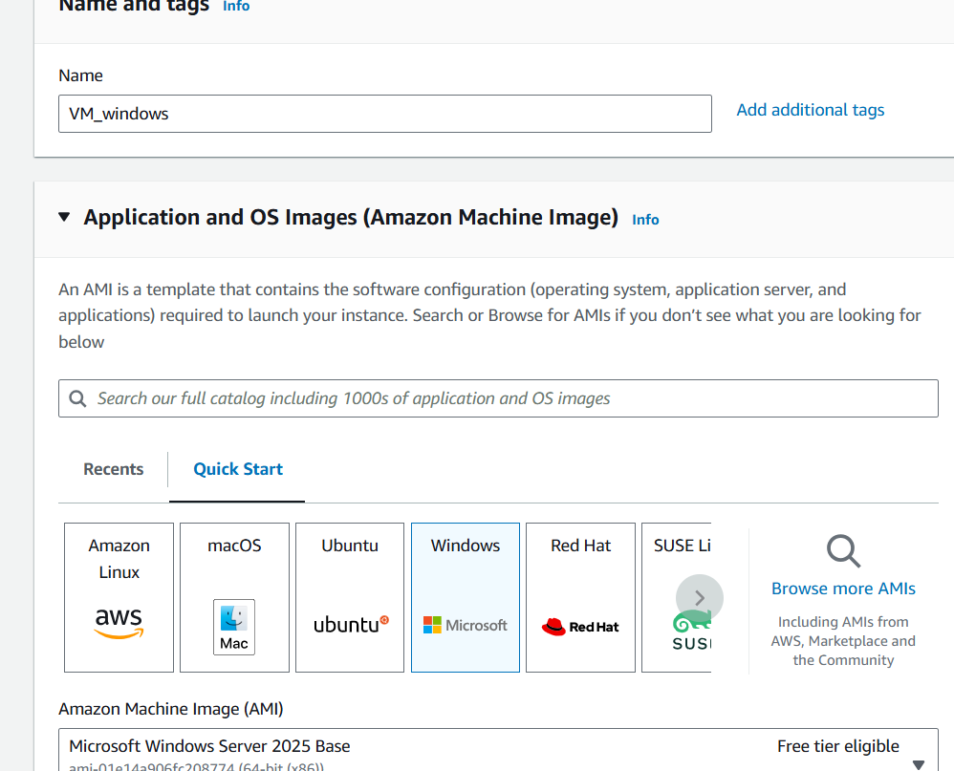

Make sure RDP port is enable in security groups to access the VM port no ( 3389 )

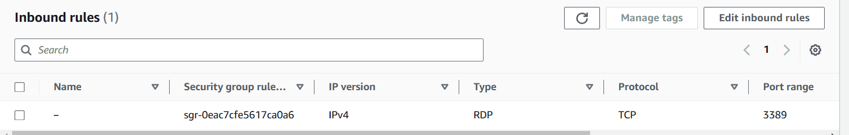

Download the RDP file session and password as well from console to connect the session and can view the system info

